Priya Sharma adjusted her blazer, her reflection faintly visible on the polished boardroom table at Blackstone Asset Management. This was it: the final round for the Junior Equity Analyst position. Her last two months of interviews, financial modelling tests, and stock pitches had all led to this moment.
David Chen, the Senior Portfolio Manager for the firm's Global Industrials fund, slid a folder across the table. "Priya, welcome," he began, his tone professional and direct. "We've been impressed so far. This is the final test. It's a real-world problem we're tackling right now. The warehouse automation sector is exploding, driven by e-commerce and supply chain pressures. We're looking to make a significant, long-term allocation, and it's come down to two key players: RoboLogic Inc. and Kinetic Systems Corp."
He paused, letting the weight of the task settle. "On the surface, they look very different. RoboLogic is the disruptor, pursuing a volume-based, market-share-at-all-costs strategy. They produce standardized, modular robotic units and compete aggressively on price. Their revenue growth is staggering. Kinetic Systems, on the other hand, follows a value-based, integrated solutions strategy. They develop bespoke, high-performance robotics systems that are deeply integrated with a client's own software. They compete on performance and customization, commanding premium prices, but their growth is more measured."
"Your mandate," David continued, "is to look past the headlines. I don't want a story about who is growing faster. I want to know who is building a better, more sustainable business. The folder contains four years of financial statements for both companies. Use them to analyze their operational efficiency, liquidity management, profitability, and capital structure. Your recommendation must be backed by a rigorous, ratio-driven analysis. This is your final test. You have three hours”.
Priya opened the folder. Her task was clear: dissect the numbers, uncover the true story behind the strategies, and make the call.
RoboLogic Inc. Consolidated Income Statement & Balance Sheet
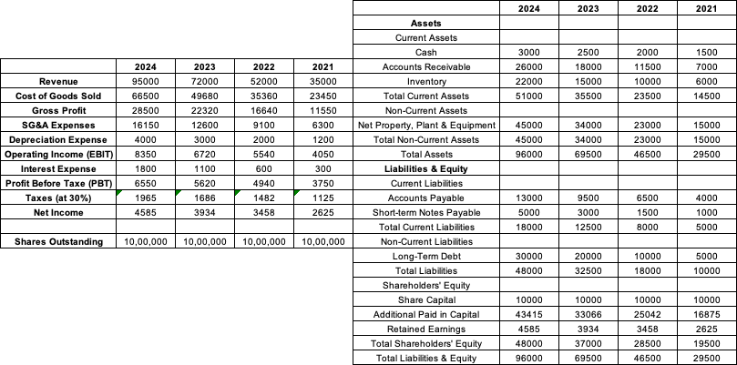

Kinetic Systems Corp. Consolidated Income Statement & Balance Sheet

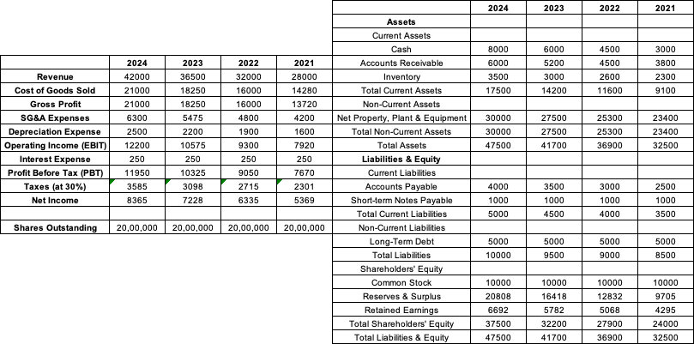

- For the year 2024, calculate the Current Ratio and Quick Ratio for both RoboLogic and Kinetic Systems.
- An industry benchmark for DSO is 90 days. Calculate the DSO for both companies for 2023 and 2024 and comment on their inventory management efficiency relative to the benchmark.
- Calculate the Total Asset Turnover for both companies for 2024. Explain what this ratio indicates about their respective business strategies.
- Calculate the Gross Profit Margin and Net Profit Margin for both companies for the years 2023 and 2024. Which company is more profitable at the margin level, and why might this be the case given the case description?
- Calculate the Debt-to-Equity ratio for RoboLogic for all four years (2021-2024). Describe the trend and explain its potential implications for the company's risk profile.
- Calculate the Earnings Per Share (EPS) for both companies for 2024.
- Current stock price of RoboLogic is $36.68 and for Kinetic Systems is $83.65, calculate the Price-to-Earnings (P/E) ratio for both companies. What does the difference in their P/E ratios suggest about investor expectations?
- A junior colleague states, "RoboLogic is clearly the better-run company; its revenue has nearly tripled in four years, while Kinetic's has only grown by 50%." Critique this statement using your calculations of both companies' liquidity and activity ratios over the four-year period. Justify your critique with at least two specific ratio trends.
- In 2024, Kinetic Systems has a significantly lower Current Ratio than RoboLogic. Does this automatically mean Kinetic has a higher liquidity risk? Explain your reasoning, incorporating your analysis of both companies' DSO.
- Calculate the Return on Equity (ROE) for both companies for 2024.
- Assume RoboLogic's management wants to improve its Quick Ratio in 2025 without reducing its current liabilities. Identify two distinct actions they could take by manipulating components of the balance sheet and income statement.
- Calculate the Interest Coverage Ratio for RoboLogic for 2023 and 2024. What does the trend in this ratio reveal about the company's ability to service its debt, especially in light of its aggressive growth strategy?
- Kinetic Systems has a significantly lower Total Asset Turnover than RoboLogic. Is this a sign of inefficiency? Justify your answer by linking the ratio back to Kinetics’ stated business strategy of providing high-value, customized solutions.
- You must now present your final recommendation to the portfolio manager. Which company, RoboLogic Inc. or Kinetic Systems Corp., represents a more fundamentally sound long-term investment? Justify your choice using a comprehensive argument that synthesizes your findings on profitability, operational efficiency, liquidity, and financial risk.

